Class Activities Post-Visit
- Have students discuss how the visit to Moundville changed or reinforced their ideas about Indians.

- Again discuss the purpose of the mounds at Moundville. What did the students learn about their function?

- Emphasize the fact that Moundville was a real town with very real people by having students do some of the following:

  - Build a model wattle and daub Mississippian house, or more ambitiously, a model village with a mound and palisade!

  - Have students write about the daily life of a boy or girl at Moundville.

- Use the attached images once again and ask your students what some of the symbols now mean to them, most particularly the eye and hand design.

- Tell your class the enclosed story of The First Fire: A Cherokee Tale. Other books based on Native American stories can be found at your local library.

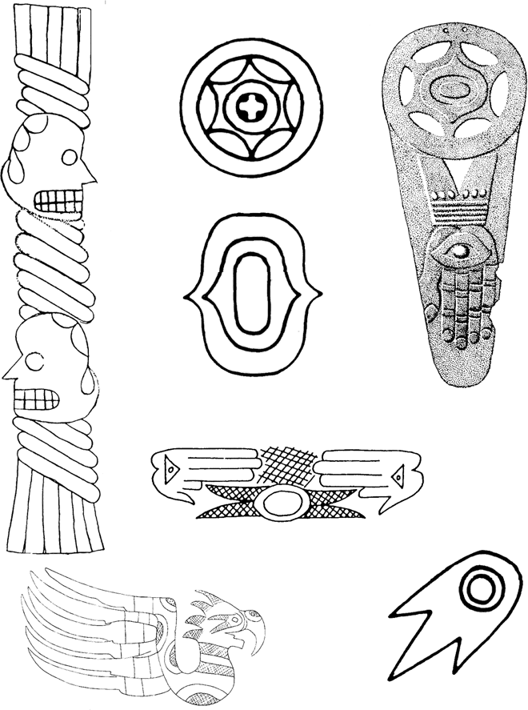
Here are some images found on artifacts made of clay, stone and copper. What do you think they mean?

The First Fire: A Cherokee Tale
In the beginning, there was no fire and the world was cold. Then the Thunders, who lived in the Upper World, sent their lightning and put fire into the bottom of a hollow sycamore tree which grew on an island. The animals knew it was there because they could see the smoke, but they could not get to it on account of the water all around. So they held a council to decide what to do.

Every animal that could fly or swim was eager to go after the fire. First, the Raven offered.
Because he was so large and strong, the other animals thought he could do the work. He flew high and far across the water and alighted on the sycamore tree, but while he was wondering what to do next, the heat scorched all his feathers black. He was frightened and came back without the fire.

The little Screech owl volunteered to go. He reached the place safely, but while he was looking down into the hollow tree, a blast of hot air came up and nearly burned out his eyes. He managed to fly home as best he could, but his eyes are red to this day. The Hooting Owl and the Horned Owl went, but by the time they got to the hollow tree, the fire was burning so fiercely that the smoke nearly blinded them. The ashes carried up by the wind made white rings about their eyes, but with all their rubbing, they were never able to get rid of the rings.

No more of the birds would venture out, and so the small Black Racer snake said he would go through the water and bring back some fire. He swam across to the island and crawled through the grass to the tree. He went in by a small hole at the bottom. The heat and smoke were too much for him. After dodging about blindly over the hot ashes, he managed to get out again. His body was scorched black, and ever since he darts and doubles on his track as if trying to escape from close quarters.

The great Black Snake - “The Climber” - offered to go for fire. He swam over to the island and climbed up the tree on the outside, but when he put his head down into the hole, the smoke choked him so that he fell into the burning stump. Before he could climb out again, he was as black as the Black Racer.

So the animals held another council. There still was no fire, and the world was cold. But the birds, snakes and four-footed animals all had some excuse for not going because they were afraid. At last the Water Spider with the black downy hair and red stripes on the body said she would go. She can run on top of the water or dive to the bottom, so there was no problem in getting to the island. But the animals questioned as to how she could bring back the fire, “I’ll manage that,” said the Water Spider.
So she spun a thread from her body and wove it into a little bowl which she fastened on her back. Then she ran across the water to the island and through the grass to where the fire was still burning. She put one little coal of fire into her bowl and returned.

Ever since, we have had fire. And the Water Spider still keeps her little bowl.
(From Mooney 1900:240-242, adapted from NatureSouth Volume 1, Number 4)

